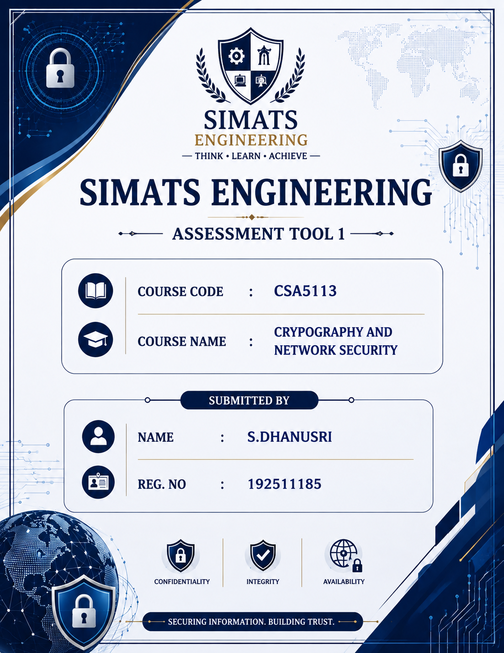

1. RSA Encryption Analysis
Given:
- Prime numbers: p = 11, q = 13
- Public exponent: e = 7
- Plaintext message: M = 9
(a) Compute n and ϕ(n)
The RSA modulus is calculated as:
$$n=p×q \\ n=11×13=143$$
Euler's Totient Function is calculated as:
$$ϕ\left(n\right)=\left(p-1\right)\left(q-1\right) \\ ϕ\left(n\right)=\left(11-1\right)\left(13-1\right) \\ =10×12=120$$
Answer:
- n = 143
- ϕ(n) = 120

(b) Find the Private Key (d)
The private key d satisfies the equation:
$$e×d≡1 \left(mod 120\right)$$
Substituting e = 7,
$$7d≡1 \left(mod 120\right)$$
Using the Extended Euclidean Algorithm,
$$d=103$$
Verification:
$$7×103=721 \\ 721 mod 120=1$$
Hence,
Private Key = (103,143)

(c) Encrypt the Message
RSA encryption formula:
$$C=M^{e} mod n$$
Substituting the values,
$$C=9^{7} mod 143$$
After modular exponentiation,
$$C=48$$
Therefore,
Ciphertext = 48

(d) Decrypt the Ciphertext
RSA decryption formula:
$$M=C^{d} mod n$$
Substituting,
$$M={48}^{103} mod 143$$
Using modular exponentiation,
$$M=9$$
The decrypted message is the same as the original plaintext.
Therefore, RSA encryption and decryption are verified successfully.

(e) Effect of Changing e
The value of e directly affects encryption speed and security.
- A smaller value of e performs encryption faster.
- If e is chosen incorrectly, it may make the RSA system vulnerable to attacks.
- A larger value of e increases computation time but provides stronger protection against certain attacks.
- The value of e must always satisfy:
  - $1<e<ϕ\left(n\right)$
  - gcd(e,ϕ(n)) = 1

Conclusion: A suitable value of e provides a balance between security and performance.

2. Block Cipher Mode Evaluation
Given
Plaintext blocks
P1 = 1010
P2 = 1010
P3 = 1111
P4 = 1010
Key
K = 1100
Initialization Vector (IV)
0000
Assume encryption operation is XOR.

(a) ECB Mode Encryption
Formula:
$$Ciphertext=Plaintext⊕{K}ey$$
Block 1
1010 ⊕1100
=0110
Block 2
1010⊕1100
=0110
Block 3
1111⊕1100
=0011
Block 4
1010⊕1100
=0110
Therefore,
ECB Ciphertext
0110 0110 0011 0110

CBC Mode Encryption
Formula:
Each plaintext block is first XORed with the previous ciphertext block.
Block 1
P1⊕IV
1010⊕0000
=1010
1010⊕1100
=0110
C1=0110

Block 2
1010⊕0110
=1100
1100⊕1100
=0000
C2=0000

Block 3
1111⊕0000
=1111
1111⊕1100
=0011
C3=0011

Block 4
1010⊕0011
=1001
1001⊕1100
=0101
C4=0101
Therefore,
CBC Ciphertext
0110 0000 0011 0101

(b) Comparison
ECB Output
0110 0110 0011 0110
CBC Output
0110 0000 0011 0101
ECB produces identical ciphertext for identical plaintext blocks.
CBC generates different ciphertext even when plaintext repeats because every block depends on the previous ciphertext.

(c) Analysis
ECB Mode
- Easy to implement.
- Supports parallel encryption.
- Reveals repeated patterns.
- Less secure for image and document encryption.
CBC Mode
- Each block depends on the previous ciphertext.
- Hides repeated patterns effectively.
- More secure than ECB.
- Requires an Initialization Vector (IV).
Conclusion: CBC mode is more secure because it prevents attackers from identifying repeated plaintext patterns.

3. DES vs 3-DES vs Blowfish Performance Study
Given
Algorithm | Key Size | Time per Block
DES | 56 bits | 2 ms
3DES | 168 bits | 6 ms
Blowfish | 128 bits | 1 ms
Number of blocks = 1000
(i) Total Encryption Time
DES
$$1000×2=2000ms$$
=2 seconds
3DES
$$1000×6=6000ms$$
=6 seconds
Blowfish
$$1000×1=1000ms$$
=1 second
Algorithm | Total Time
DES | 2 seconds
3DES | 6 seconds
Blowfish | 1 second

(ii) Trade-Off Analysis
DES
- Uses a 56-bit key.
- Fast encryption.
- Easily broken using brute-force attacks.
- Not recommended for modern applications.
3DES
- Uses three DES operations.
- Much stronger than DES.
- Slowest among the three algorithms.
- High computational cost.
Blowfish
- Supports key sizes up to 448 bits.
- Fast encryption speed.
- High level of security.
- Suitable for large amounts of data.

(iii) Recommendation
For secure real-time communication, Blowfish is the best choice because it provides:
- Fastest encryption speed.
- Strong security.
- Low processing time.
- Better efficiency than DES and 3DES.

4. Diffie–Hellman Key Exchange
Given
p = 23
g = 5
Private key of A = 6
Private key of B = 15

(a) Compute Public Keys
For User A
$$A=g^{a} mod p \\ A=5^{6} mod 23=8$$
Public Key of A = 8
For User B
$$B=5^{15} mod 23=19$$
Public Key of B = 19

(b) Compute Shared Secret Key
For User A
$$K={19}^{6} mod 23=2$$
For User B
$$K=8^{15} mod 23=2$$
Therefore,
Shared Secret Key = 2

(c) Man-in-the-Middle (MITM) Attack
A malicious attacker intercepts the public keys exchanged between User A and User B. Instead of forwarding the original keys, the attacker sends fake public keys to both users. As a result, User A establishes a secret key with the attacker, believing it belongs to User B, and User B establishes another secret key with the attacker, believing it belongs to User A. The attacker can then decrypt, modify, and re-encrypt all communication without either user realizing it.

(d) Prevention
The following methods can prevent MITM attacks:
- Digital Signatures
- Digital Certificates (PKI)
- Authenticated Diffie–Hellman Protocol
- SSL/TLS Protocols
These methods verify the identity of both users before establishing the shared secret.

5. ECC vs RSA Comparison
Given
RSA Key Size = 1024 bits
ECC Key Size = 160 bits
Target Device = IoT Device with Limited Resources

(a) Computational Cost
RSA requires large key sizes, resulting in higher computational complexity and longer processing time. Encryption and decryption operations consume more CPU resources.
ECC achieves the same security level using much smaller keys. It performs faster mathematical operations, making it computationally efficient.

(b) Power and Memory Consumption
RSA:
- Larger key storage requirements.
- Higher RAM usage.
- Increased battery consumption.
- Less suitable for low-power devices.
ECC:
- Smaller key size.
- Lower memory usage.
- Lower power consumption.
- Faster execution.

(c) Justification
For IoT devices with limited processing capability, ECC is the better cryptographic system because it provides equivalent security to RSA while using much smaller keys. It reduces computational overhead, consumes less memory and power, and offers faster execution. Therefore, ECC is widely used in mobile devices, wireless sensors, smart cards, and Internet of Things (IoT) applications.

Conclusion: ECC is the most suitable choice for resource-constrained environments due to its high security, efficiency, and low power consumption.

